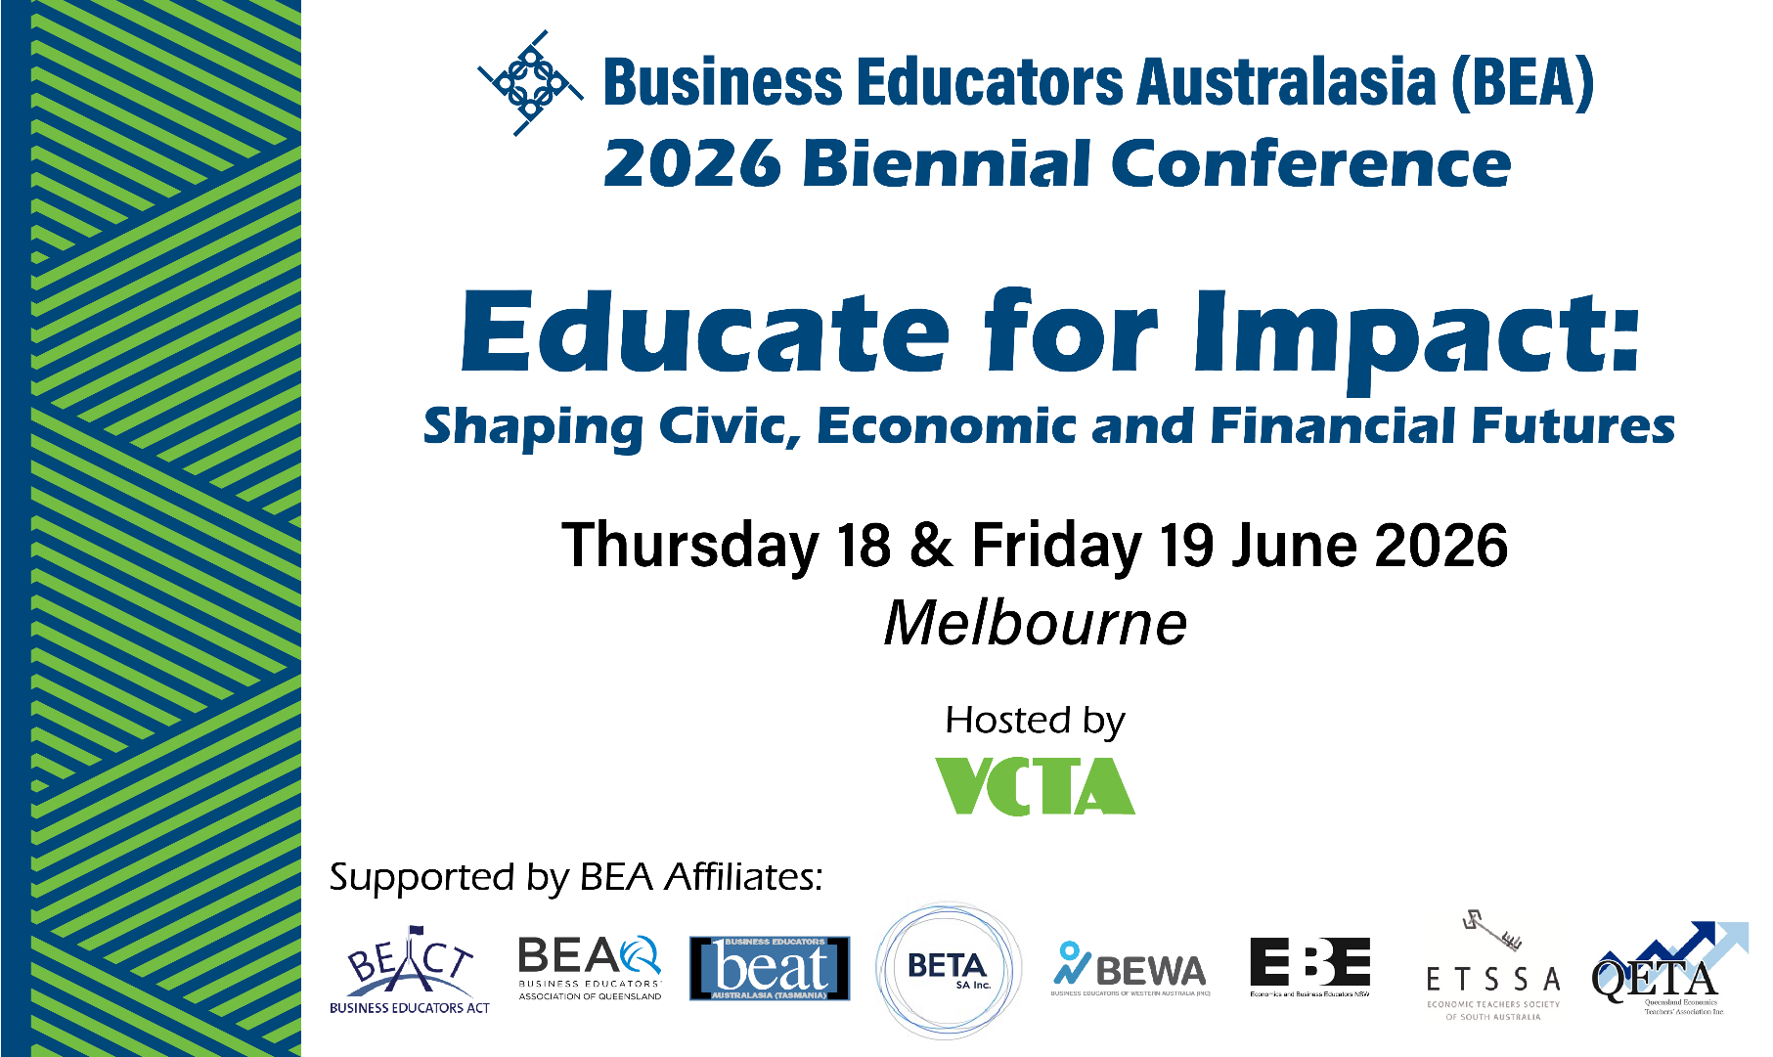

PROFESSIONAL LEARNING GRANTS
Your opportunity to travel to Melbourne and attend the 2026 BEA Biennial Conference

Join us at the 2026 BEA Biennial Conference in Melbourne to be part of a national conversation about how we educate for impact… shaping success for every student’s future in life, work and the community.
In a time of cost-of-living pressures, economic uncertainty and democratic principles under threat, Economics and Business and Civics and Citizenship education for every Australian student matters more than ever!
The Conference will provide an outstanding opportunity to network and learn alongside business educators from across Australia, with a program featuring high-quality speakers and workshop sessions focused on Years 7–10 Economics and Business and Civics and Citizenship education.
To assist early-career teachers to participate in this national conference, BEA in conjunction with the VCTA, is sponsoring two professional learning grants worth over $1,100.

Each grant includes:
- Two-day registration to attend the conference, including morning tea and lunch on both days.
- $650 (including GST) to put towards travel and/or accommodation.

AM I ELIGIBLE?
You are eligible if you:
- are an early-career teacher with five years or less teaching experience
- teach one or more of the following curriculum areas: Economics and Business, Civics and Citizenship
- are a current financial member of a Business Educators Australasia affiliate.

HOW CAN I APPLY?
Submit an application to your local state or territory BEA affiliate association of 500 words or fewer responding to the following question:
- How would attending the 2026 BEA Conference help you educate for impact by shaping civic, economic and financial futures, while supporting your teaching practice, benefiting your teacher association and influencing your classroom teaching over the next two years?
We are seeking genuine responses that reflect your own experience, passion and commitment to business education. Applications should be written in your own words and not generated using artificial intelligence tools.

WHEN & WHERE DO I APPLY?
Applications must be submitted by no later than 27 March 2026 to your local BEA affiliate association, of which you are a financial member.
Please include the following information in your application, along with your response to the question below.
First Name:
Surname:
School:
BEA Affiliate Association:
Mobile Number:
Email:
Declaration:
☐ I confirm that this application is written in my own words, reflects my personal experience, passion and commitment to Business education, and has not been generated using artificial intelligence tools.
☐ If selected for the professional learning grant, I can confirm that my workplace will approve my attendance at the conference in Melbourne.

For further information contact your State/Territory affiliate association or contact the BEA on 1800 631 203 or office@bea.asn.au

INFORMATION FOR {INSERT STATE, TERRITORY or AFFILIATE’s NAME} APPLICANTS
BEA Affiliate Association: |  | {Insert your Logo}
Email: |  | {Insert your Logo}
Phone Number |  | {Insert your Logo}

