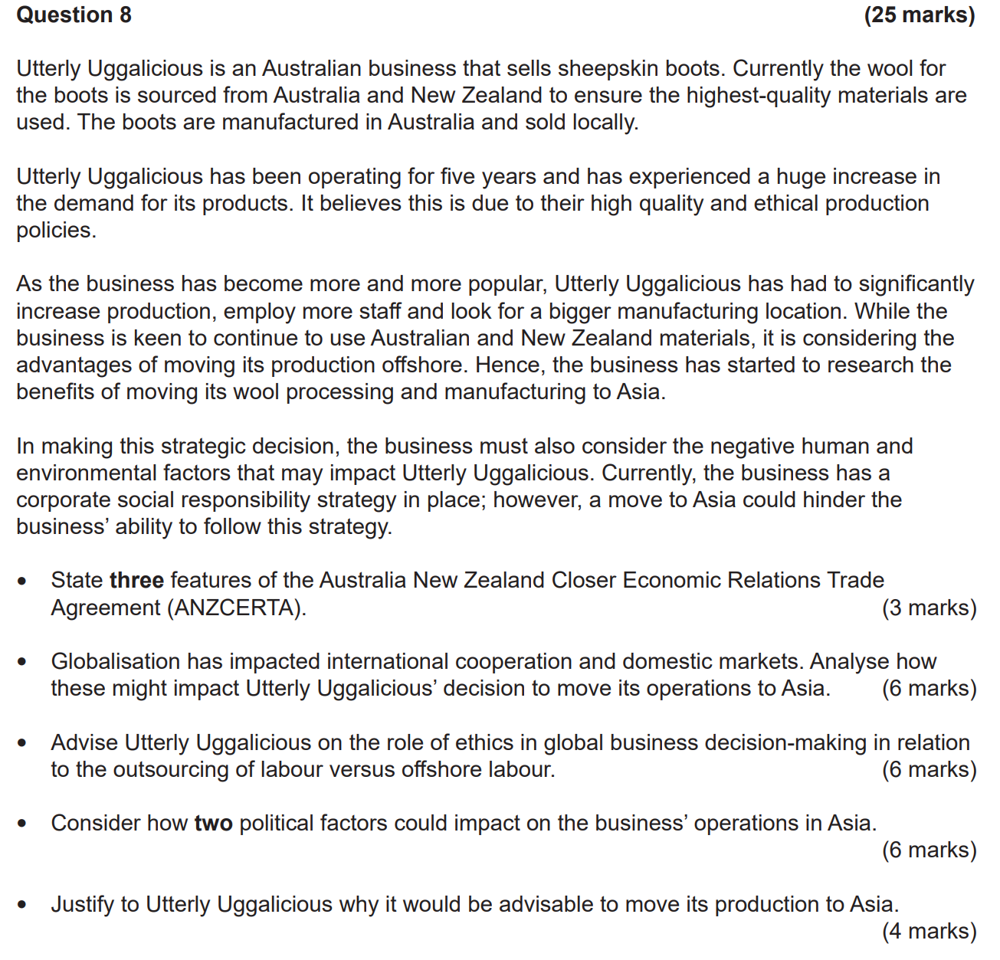

FEATURES OF FTA (ANZCERTA) |  | ETHICS Outsourcing
IMPACT International Cooperation |  | ETHIC Offshoring
IMPACT Domestic Market |  | POLITICAL Stability
Is it advisable?  REASONS/JUSTIFY |  | POLITCAL International Relationships

