Year 12 Accounting and Finance Project

School-based assessment
The Western Australian Certificate of Education (WACE) Manual contains essential information on principles, policies and procedures for school-based assessment that needs to be read in conjunction with this syllabus.
Teachers design school-based assessment tasks to meet the needs of students. The table below provides details of the assessment types for the Accounting and Finance ATAR Year 11 syllabus and the weighting for each assessment type.

Assessment table – Year 11
Type of assessment | Weighting
Project  Students scrutinise accounting and finance issues; analyse, critique and interpret given situations; examine references and sources; make conclusions; and present the results of their open-ended or directed tasks.  This can involve: researching accounting and finance data; investigating products/services within the accounting and finance area; responding to given scenarios.  The project requires students to draw conclusions and make recommendations.  Formats can include: scaffolded questions, formal reports, written presentations or multimedia presentations, or a combination of these.  Students can work individually or in a group. | 10%

Government and the community

The influence of social, environmental and ethical factors

• identification of the costs and potential income associated with engaging in socially and environmentally responsible practices
• the ethical issues encountered in financial dealings between business owners/managers and their employees, clients and investors

The influence of social, environmental and ethical factors

• the extent and nature of corporate social disclosure
• the difficulties faced by accountants in producing social and environmental information
• the use made of corporate social disclosure by the company and other users
• critical evaluation of corporate social disclosure as made by Australian companies

“None of our other objectives described above would be possible without trust, meaningful relationships and mutually beneficial partnerships. This is our social licence to operate. It is judged by others and is essential for our long-term future. The 24th of May 2021 marked one year since the destruction of the rock shelters at Juukan Gorge in Western Australia. Earlier in the year, I was very grateful to meet with the Puutu Kunti Kurrama and Pinikura (PKKP) people on their land and personally express my sincere regret for the damage. Being there with them had a profound impact on me. At the end of 2021, the relationship between the PKKP leadership and Rio Tinto Iron Ore is constructive and considered. Together, we are charting new territory. This takes time, but we are moving forward on a model which is respectful and looks to provide certainty of protection for cultural heritage and mining.”
Jakob Stausholm Rio Tinto Chief Executive
23 February 2022

Year 12 Accounting and Finance Project
Task One
The influence of social, environmental and ethical factors

Over the past few decades, discussion on corporate governance and corporate social responsibility (CSR) has become more commonplace. Companies link their operations to generating positive long-term value, both for the business and for the community. However, when things go wrong there can be negative impacts on the business and its stakeholders.

- Explain the nature of CSR and describe how CSR contributes to the long-term income stream of an organisation.

- Describe a specific example of an Australian business engaging in socially responsible and ethical practices.

- Discuss THREE costs and THREE potential income (benefits) of a business engaging in socially responsible and ethical practices.

Rio Tinto Ltd, an Australian listed mining company, destroyed a 46,000 year old site at Juukan Gorge considered sacred by the Puutu Kunti Kurrama and Pinikura people. The explosion of the caves and waterhole during planned expansion of mining operations was legally sanctioned by the Aboriginal Heritage Act. The destruction led to worldwide condemnation and outrage by investors.

- Provide an assessment of the impact of the Juukan Gorge explosion on the following stakeholders:
  - Shareholders/investors
  - managers (directors)
  - employees
  - clients
  - wider community

- Describe the extent and nature of corporate social disclosure.

- Identify THREE uses made of corporate social disclosures by the company in relation to the Juukan Gorge.

REQUIRED
Option A
In pairs research the Juukan Gorge explosion and its impact on stakeholders of Rio Tinto Ltd.
Prepare a Podcast answering the questions outlined in the task. Your Podcast must be 6 minutes. Use sound-editing software, like Audacity, which is available online as a free download.
Option B
In pairs research the Juukan Gorge explosion and its impact on stakeholders of Rio Tinto Ltd.
Prepare a PowerPoint Presentation answering the questions outlined in the task. Your presentation must be no more than 20 slides, with each slide summarised to a maximum of 30 words per slide, minimum 24 font size. The presentation must be no longer than 6 minutes in duration.

Year 12 Accounting and Finance Project
Task One
The influence of social, environmental and ethical factors

MARKING RUBRIC
Student Names: _____________________________________________________________

Section | Components | Marks Allocated | Result
Relevant Accounting Theory | - Explain the nature of CSR.  Describe how does CSR contribute to the long-term income stream of an organisation  - Describe a specific example of an Australian business engaging in socially responsible and ethical practices.  - Identify THREE costs of engaging in socially, environmentally and ethically responsible behaviour.  Identify THREE potential income (benefits) of engaging in socially, environmentally and ethically responsible behaviour. | 4  2  3  3  3
Case Study | - Provide an assessment of the impact of the Juukan Gorge explosion on the following stakeholders:  - Shareholders/investors  - directors and management  - employees  - clients  - wider community  - Describe the nature and extent of corporate social disclosure.  - Identify THREE uses made of corporate social disclosures by Rio Tinto in relation to the Juukan Gorge. | 3  3  3  3  3  2  3
Presentation | Number of slides (less than 20)  Font size  Word limit  Slide quality  Introduction  Presentation content  Conclusion  Video timing limit (Acceptable under/over of 10 seconds)  Presentation quality and creativity | 1  1  1  3  2  2  2  1  2
Total |  | 50

Juukan Gorge (riotinto.com)

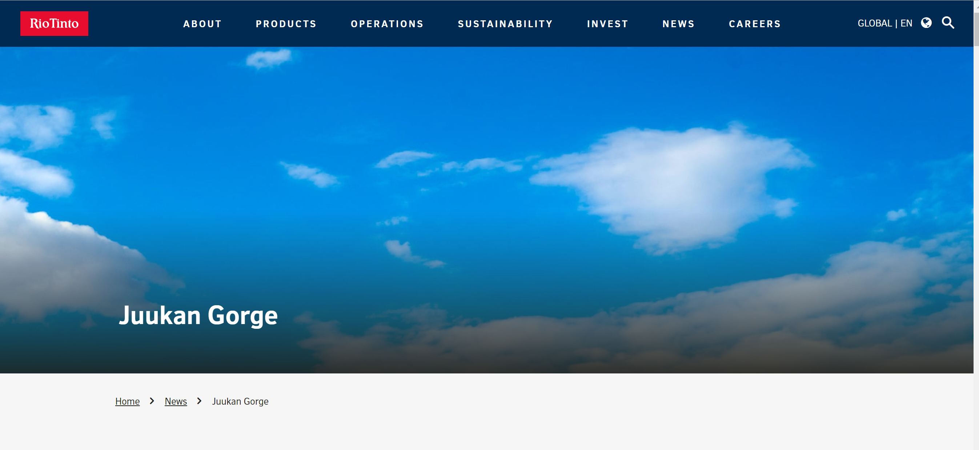

Juukan Gorge: Rio Tinto investors in pay revolt over sacred cave blast - BBC News

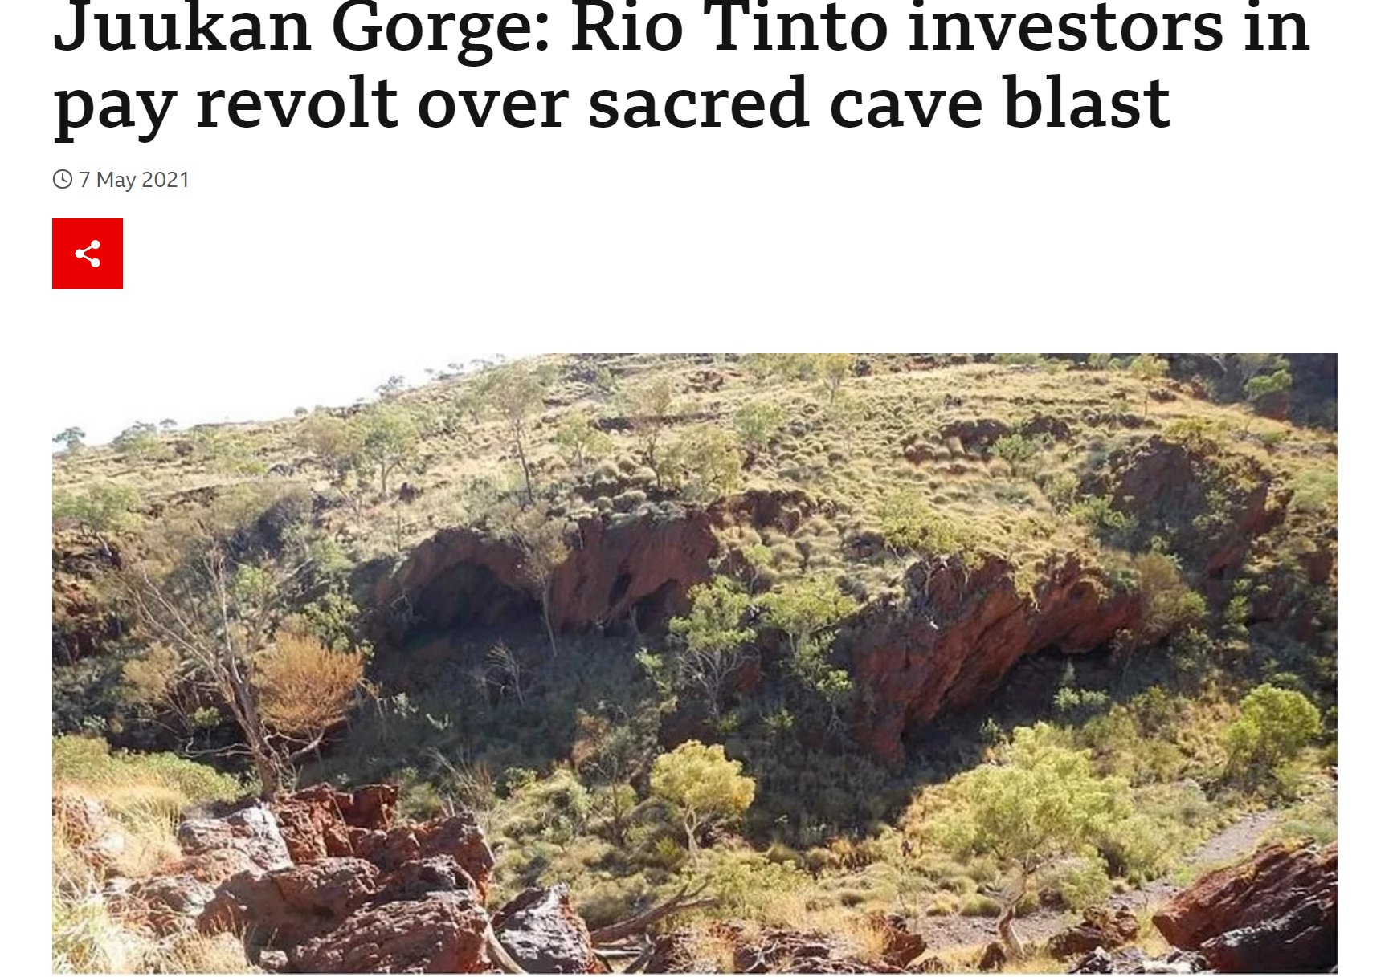

Protecting our shared future | HESTA Super Fund
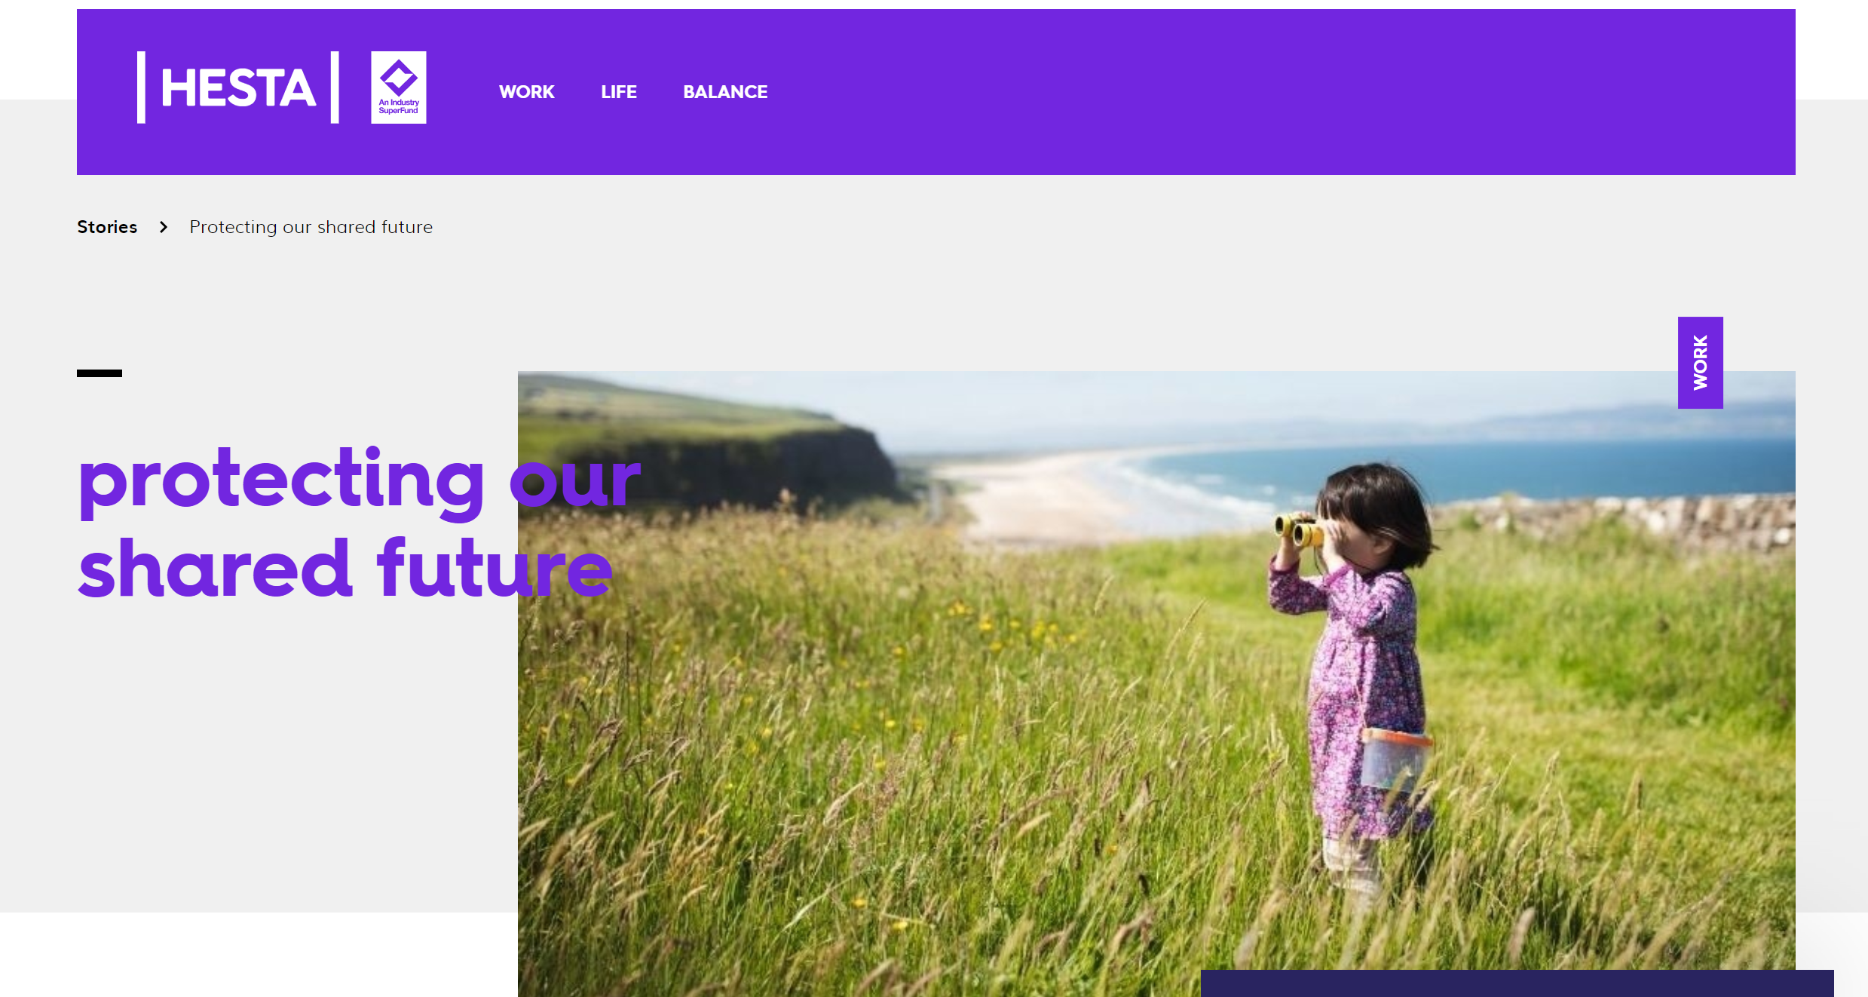

'Two incredibly painful years': Juukan Gorge anniversary renews calls for heritage protection | SBS NITV
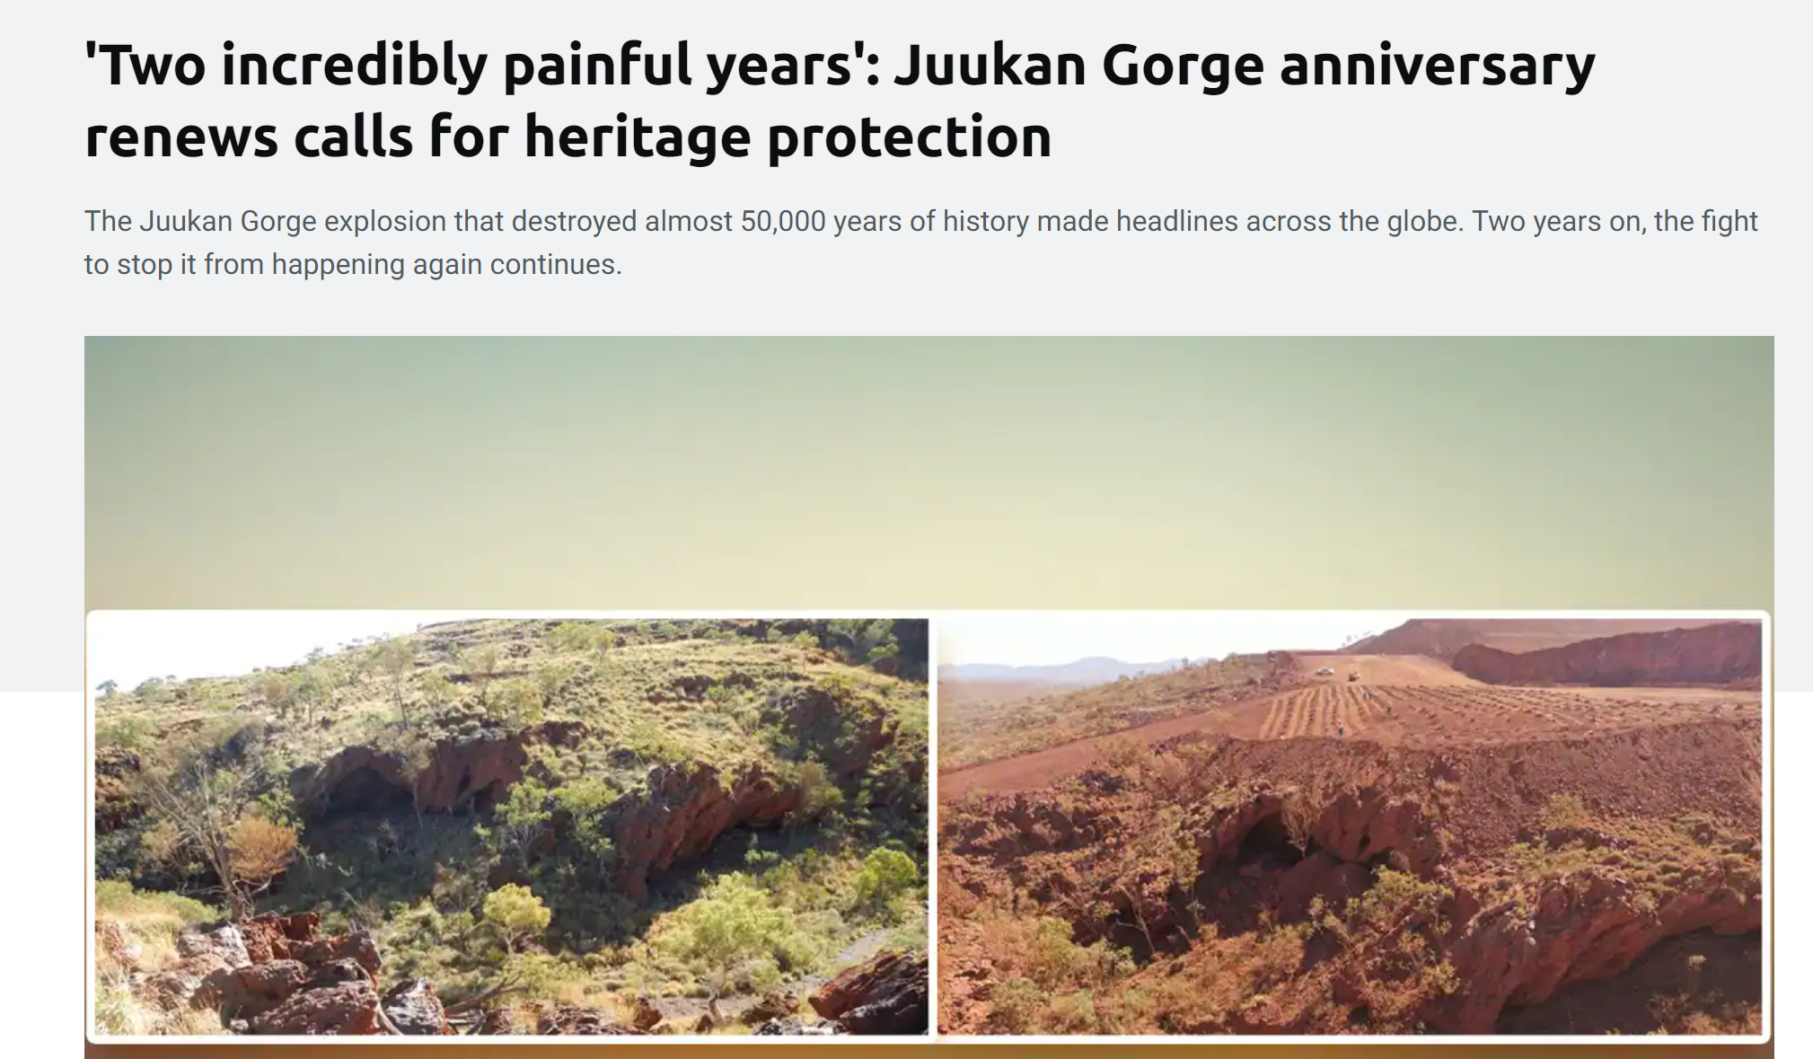

RT-Annual-report-2021 (1).pdf
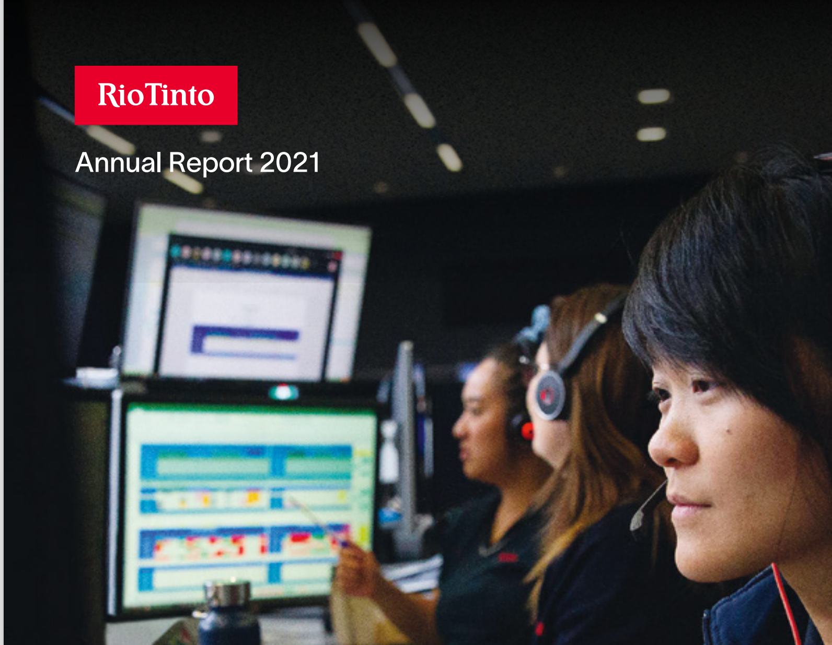

Relevant Accounting Theory
- Explain the nature of CSR. (4 marks)

Description | Marks
Full explanation requires a discussion on the following:
Identifies process and practices that enhance global and community expectations | 1
Identifies social awareness | 1
Identifies environmental awareness | 1
Identifies ethical and legal obligations | 1
Accept any other reasonable comment
Total | /4
Answer could include, but is not limited to
CSR aims to provide responsible self-regulating business practices and processes which contribute to the enhancement of society/global community/community expectations. [1] Acting and reporting in a socially aware [1] and environmentally responsible way in addition to financial outcomes [1]
and promoting ethical and legal obligations [1].

Describe how does CSR contribute to the long-term income stream of an organisation. (2 marks)

Description | Marks
Discussion on the following:
Identifies enhanced reputation | 1
Identifies improved profitability from improved customer loyalty | 1
Total | /2
Answer could include, but is not limited to
Increased customer loyalty/enhanced goodwill [1] should have an impact on long term profitability generating increased revenue streams in the long term as corporate reputation is enhanced [1].

- Describe a specific example of an Australian business engaging in socially responsible and ethical practices.
(3 marks)
Description | Marks
Discussion on the following:
Identifies an appropriate Australian business | 1
Identifies a relevant example of an Australian business engaging in socially responsible and ethical practices | 1
Describes in detail an appropriate example of an Australian business engaging in socially responsible and ethical practices | 1
Total | /3
Answer could include, but is not limited to
Australian company with relevant examples relating to:
- Donations, sponsorship and support of community projects
- Sustainable workplace practices relating to resources conservation
- Ethical practices for employees (pay, conditions, diversity)
- Abide by laws and regulations
- Ethical corporate governance standards

- Identify THREE costs of engaging in socially, environmentally and ethically responsible behaviour.
(3 marks)
Description | Marks
Discussion on the following:
Identifies one cost | 1
Identifies two costs | 2
Identifies three costs | 3
Total | /3
Answer could include, but is not limited to
Australian company with relevant examples referring to:
- Increased expenditure on sustainable practices
- Increased reporting responsibilities
- Employing skilled expertise and training employees

Identify THREE potential income (benefits) of engaging in socially, environmentally and ethically responsible behaviour.
(3 marks)
Description | Marks
Discussion on the following
Identifies one benefit | 1
Identifies two benefits | 2
Identifies three benefits | 3
Total | /3
Answer could include, but is not limited to
Australian company with relevant examples relating to:
- Increased customer loyalty and profitability
- Increased reputation/goodwill increased investment and profitability
- Attract staff and reduce employee turnover and recruitment costs

- Provide an assessment of the impact of the Juukan Gorge explosion on the following stakeholders: (15 marks)
  - Shareholders/investors
  - directors and management
  - employees
  - clients
  - wider community

Description | Marks
See below for each stakeholder
Provides detailed evidence from research | 3
Provides specific reference to the case study | 2
Identifies an impact on the stakeholder | 1
Sub Total | /3
Total | /15
Answer could include, but is not limited to
Provide an assessment of the impact of the Juukan Gorge explosion on the following stakeholders:
- Shareholders/investors
Shareholders and investors are predominately interested in long term growth and sustainability. They are looking for a return on their investment. Increasingly, investors and shareholders expect and needs companies to deliver both economic and social value.
Investors demonstrated that they will not accept corporate misinformation and the absolute disrespect to cultural sites.
Over 60% of the shareholders of the company voted against the firm’s executive remuneration package at the annual general meeting
On September 10 2020, Hesta Superannuation, a major Rio Tinto shareholder, released a Statement on Working with Indigenous Communities (pdf) detailing investor expectations around how companies manage risks associated with Indigenous heritage protection issues.
- managers and directors
Directors must carry out their duties with due care and diligence.
The CEO and two other senior executives were forced to leave the company. The reputation of the executive team was irreparably damaged. The company was held accountable for poor ethical standards.
- employees
Employees play a crucial role in the success of an organisation. Attracting and retaining the best employees should be a priority.
Many of the company’s employees felt sorry and ashamed after the destruction of the Juukan Gorge.
Communities staff deserved to be supported, especially in relation to indigenous workers.
- clients
Substantial damage was done to the relationship with indigenous community, the Puutu Kunti Kurrama People (PKKP). This broken trust will need to be supported and future transparency will need to be encouraged in the mining industry.
- wider community (lenders, suppliers, government agencies)
The impact of the Juukan Gorge explosion was widespread. A Parliamentary inquiry was ordered, and Rio Tinto was forced to rebuild the cave system. The inquiry made seven recommendations, including a moratorium on all mining in the local area, and changes to heritage protection laws.

Rio Tinto would cooperate with Joint Standing Committee on Northern Australia’s Inquiry into the destruction and support the WA Government in reforming the Aboriginal Cultural Heritage Act.

Many of the recommendations to come out of the inquiries into the events that took place at the Juukan Gorge have had an impact on other Australian mining companies and stakeholders and within the wider community.

- Describe the nature of corporate social disclosure. (2 marks)
Description | Marks
Discussion on the following
Identifies communication of CSR | 1
Description of reporting to stakeholders | 1
Total | /2
Answer could include, but is not limited to
CSD is about communicating the success or otherwise of a business’s efforts in regard to social, environmental and ethical impacts. [1] It refers to the reporting of CSR policies, practices and performance to stakeholders in annual reports, media releases, on company websites. [1]

- Identify THREE uses made of corporate social disclosures by Rio Tinto in relation to the Juukan Gorge. (3 marks)
Description | Marks
Discussion on the following
Identifies one disclosure | 1
Identifies two disclosures | 2
Identifies three disclosures | 3
Total | /3
Answer could include, with specific reference to the report
annual report
sustainability report
company website
newsletters
press releases

